|  |  |  |  |
| --- | --- | --- | --- |
| **Branch: Instrumentation & Control Engineering** | | **Year:** Second Year | |
| **Division: C** | **Roll No: 04** | **GR Number: 11911180** | **Subject:** OOPS |
| **Assignment No:** | **Date of Submission: 29-04-2021** | **Student Full Name: Shaunak Sudhir Deshpande** | |

Aim: Create two classes DM and DB which stores the value in distances. DM stores distance in meters and centimeters and DB in feet and inches.

Write a program that can read values for the class objects and add one object of DM with another object of DB. Use a friend function to carry out.

the addition operation. The object that stores the results may be a DM object or DB object, depending on the units in which the results are required.

The display should be in the format of feet and inches or meters and centimeters depending on the object on display.

Software Used: MinGW, VSCode

Code:

#include<iostream>

using namespace std;

class DB; class DM

{

    float meter,centi;

    public:

    void getdata()

    {

        cout<<"\nEnter the distance in {meter-centimeter}:";

        cin>>meter>>centi;

    }

    void display()

    {

        cout<<"\nThe distance is:";

        cout<<meter<<"meters and"<<centi<<"centimeters";

    }

friend void add(DM&,DB&);

};

class DB

{

    float inch,feet;

    public:

    void getdata()

    {

        cout<<"\nEnter the distance in feet-inch";

        cin>>feet>>inch;

    }

    void display()

    {

        cout<<"\n The distance is:";

        cout<<feet<<"feet and "<<inch<<" inch";

    } friend void add(DM&, DB&);

};

void add(DM &a, DB &b)

{

    int ch;

    cout<<"\nPress 1 for meter-centi:\nPress 2 for feet-inch:\n";

    cin>>ch;

    if(ch==1)

    {

        DM d;

        int c=(a.meter*100 + a.centi + b.feet*30.48 + b.inch*2.54);

        if(c>100)

        {

            d.meter= c/100;

            d.centi=c%100;

        }

        else

        {

            d.meter=0;

            d.centi=c;

        }

            d.display();

    }

    else

    {

        DB d;

        int i=(a.meter*39.37 + a.centi*0.3937008 + b.feet*12 + b.inch);

        if(i>=12)

        {

            d.feet= i/12;

            d.inch=i%12;

        }

        else

        {

            d.feet=0;

            d.inch=i;

        }

        d.display();

    }

}

int main()

{

    DM a;

    DB b;

    a.getdata();

    b.getdata();

    add(a,b);

    return 0;

}

Output:

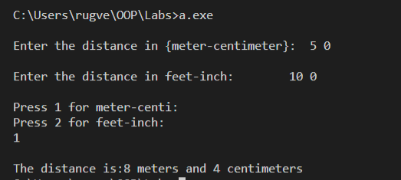

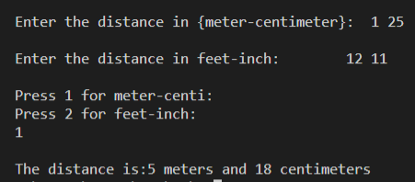

Analysis of Program:

This program is an example of adding two inputs of different units (Meter-centimeter & Feet-inch) and giving the output in a singular uniform unit (either meter or feet).

We accomplish this in C++ using classes and friend functions. We get the data from the user and then store meter centimeter data in DM and feet inch data in DB. Then we use a friend function called add, to add these two different types together and then output the data in either meter cm or in feet inch.

Conclusion:

A friend function, i.e a "friend" of a given class, is a function that is given the same access as methods to private and protected data. It’s main use is when a function needs to access private data in objects from two different classes.